**Birla Institute of Technology & Science, Pilani**

**Work Integrated Learning Programmes Division**

**First Semester 2022-2023**

**Mid-Semester Test**

**(EC-2 Regular)**

Course No. :  CSI ZG514

Course Title :  Introduction to DevOps

Nature of Exam : Open  Book

No. of Pages = 2

No. of Questions = 4

Weightage : 30%

Duration : 2 Hours

Date of Exam : 25/09/2022 (Evening)

Note to Students:

1. Please follow all the *Instructions to Candidates* given on the cover page of the answer book.
2. All parts of a question should be answered consecutively. Each answer should start from a fresh page.
3. Assumptions made if any, should be stated clearly at the beginning of your answer.
4. An organization is trying to build an application with multiple MVPs (Minimum Viable product). Time is of essence for this organization as there is a possibility that another competitor is also creating a similar kind of a project. This application needs to work in Embedded devices and browser. With the above scenario in mind, please answer the below questions: [3 + 3 + 4 = 10 Marks]
5. What is the suitable team size for this application development? Justify your answer based on the above scenario.

Ans:

Team size will be ~ 6-8 members,

Scrum master – 1

Product owner – 1

Developers -2

Ux designer -1

Testers -2

Devops engineer -1

1. What is the best suitable methodology and development to mitigate this issue? Justify your answer with relevant pointers.

Ans:

Agile -

1. Explain the steps needed for this application to become a commercial success in market. Explain all the phases needed for this application from inception to the app release.

Ans:

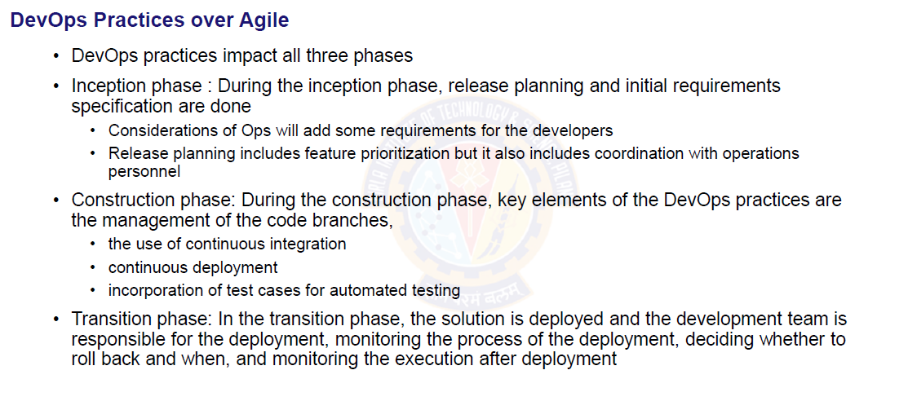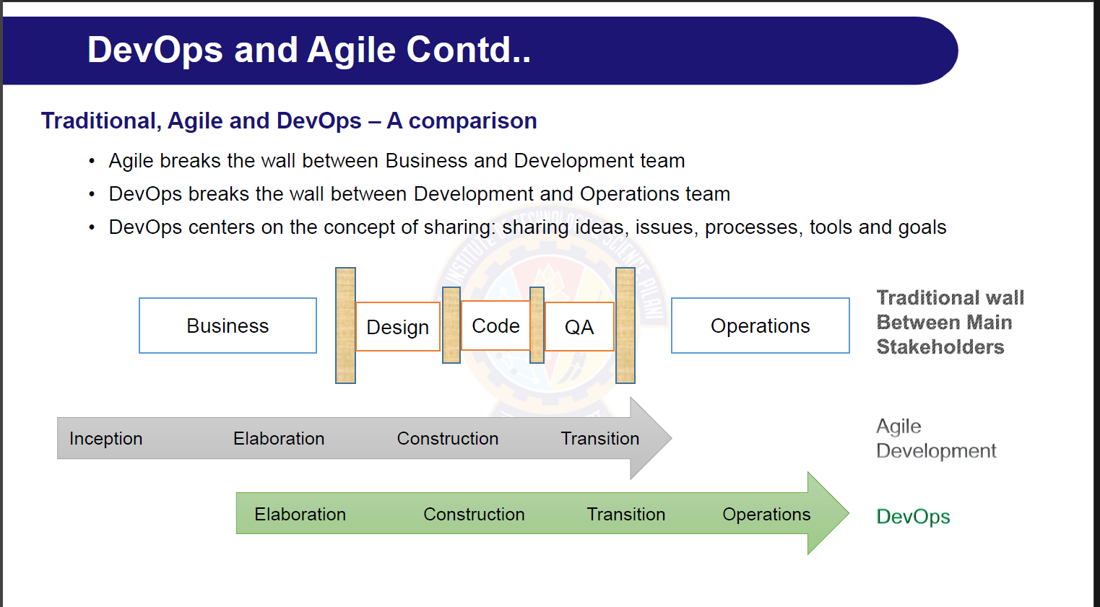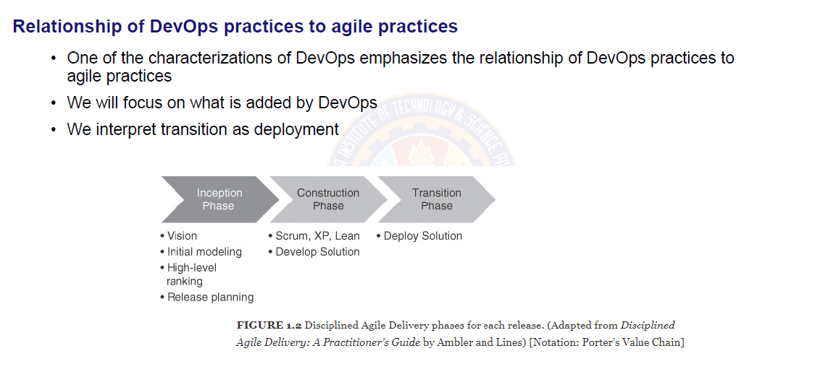

* 1. You are the DevOps administrator for a project which involves multiple teams who work on multiple platforms (Say Frontend and Backend). Each team has multiple developers, and they all work on dependent modules or on the same files and folders as this is an Agile methodology project and MVP needs to be delivered every single sprint. Considering this scenario, please answer the following questions: [3 + 3 + 4 = 10 Marks]

1. What are the steps needed to create a GitHub repository for the teams? What kind of security mechanism will you follow to ensure other teams will not be able to access this project?

Ans:

Create Github Organizations (parent project) with private access and inside project will create multiple repo with developer as collobator access. And will give access to only to the member of that group.

* + - Organizations
      1. Frontend repo
      2. Backend repo

1. In case there is a problem in a commit pushed by a developer, and you need to build the repo now and you found only during the deployment build, and it is already past midnight, and you are not able to contact the developer, what is the best way to handle this scenario?

Ans:

**Revert till last success build from history**

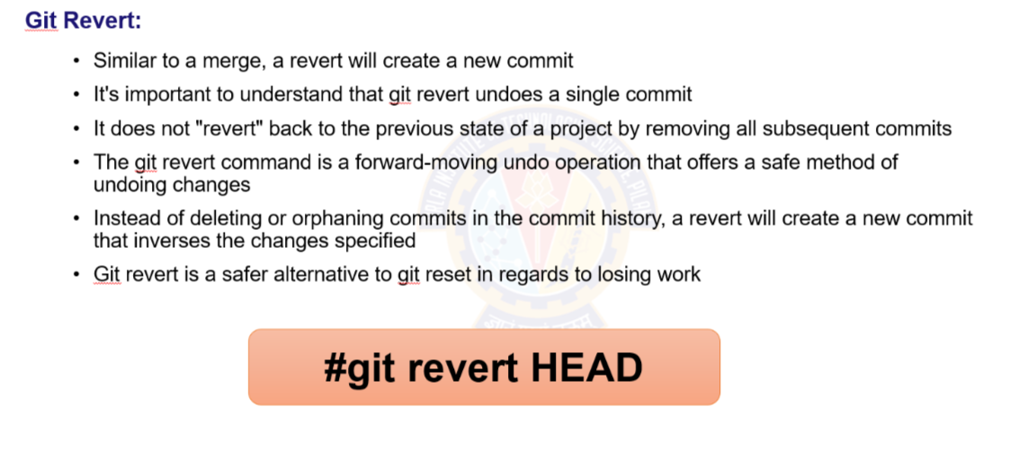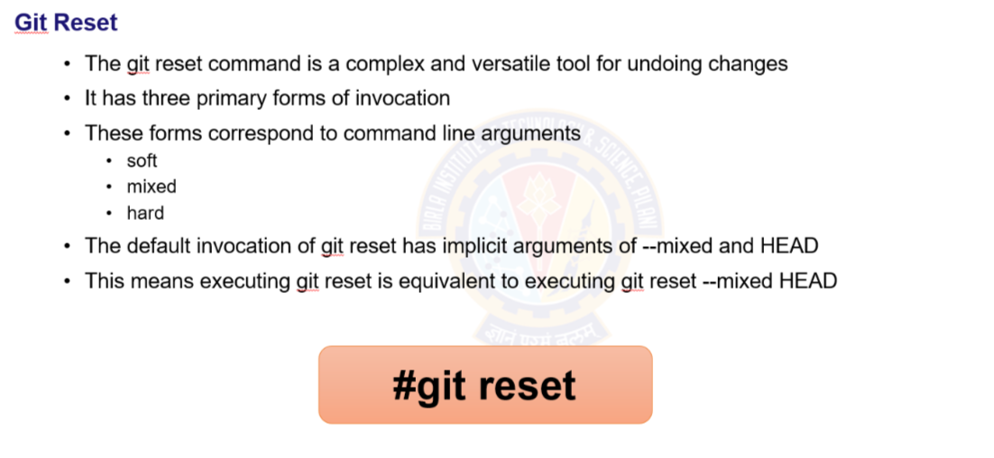

1. Two developers are working on the same file. They are touching the same function in the same file. One developer has pushed the code while another developer was committing his change. What kind of issue the second developer will face? Provide the two types of mechanism in which the second developer will fix the issue.

Ans:

Merge conflict

* + - Pull and merge
    - Commit and push

Refer from 264 (merged slide)

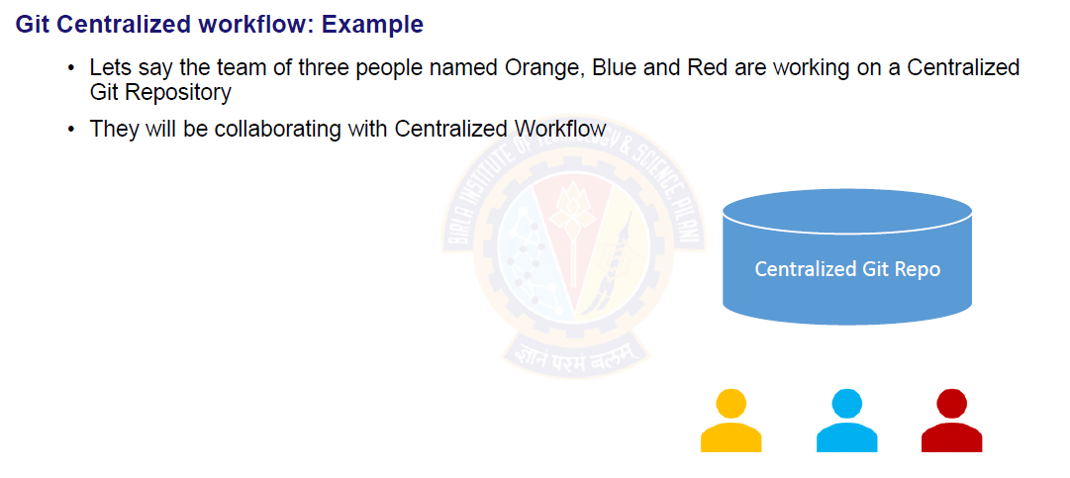

* 1. For eReservHotel application, customer proposed below functionality to be implemented:

Login and Signup page for end users to use the application. Once user gets logged in he/she can reserve the room according to their selection (City, Area, package etc.). User should be provided with the addon service of car hire during their entire stay or pick & drop facility. Rewards and discount should provide as a part of loyalty program. User should be given option to select preferred payment gateway upon completion of hotel reservation process.

Being DevOps architect,

1. Prepare and design application using component-based architecture [2 Marks]

Ans:

**Frontend components:**

• Login and Signup pages

• Room reservation form

• Car hire and pick & drop selection

• Rewards and discount program

• Payment gateway selection

**Backend components:**

• User authentication and authorization

• Room reservation management

• Car hire and pick & drop management

• Rewards and discount management

• Payment gateway integration

1. Draw the dependency graph pipeline [2 Marks]

Ans:

User Login/Signup -> Room Reservation -> Car Hire -> Loyalty Program -> Payment Gateway

1. List the benefits of component-based design [1 Mark]

Ans:

* + Loose coupled
  + Reusability
  + Security
  + Easy to use
  + Maintainability:

**ChatGpt**

* Reusability: Components can be reused across different parts of the application, reducing the amount of code duplication and making the development process faster and more efficient.
* • Scalability: As the application grows and new features are added, components can be easily modified or replaced without affecting the rest of the application.
* • Maintainability: Components are self-contained and have a clear interface, making it easier to debug and maintain the application code.
* • Separation of concerns: Components allow for a clear separation of concerns between different parts of the application, making it easier to understand and modify the application code.
  1. With Traditional Development Elita corporation is able to develop their add-on features in average span of 4 months and 1 month is reserved to make the successful testing and deployment. You been hired as consultant to derive the results by:

1. Identifying the Problem Statement [1 Mark]

Ans:

5 Month (4month development + 1 month testing)

* + Tester will be ideal for starting 3 month (initial stage)
  + Developer will have less time to fix the bug which is raised by testing team
  + which will increase time to market
  + Feedback from testing team / product owner will get in later stage

1. Proposing solution for optimized testing and deployment [2 Marks]

Ans:

Agile methodology

Devops approach – will explain about CI/CD

1. Justify the proposal [2 Marks]

Ans:

ChatGpt

By automating testing and implementing CI/CD pipelines, the development team can reduce the amount of time spent on manual testing and deployment, and ensure that new features are thoroughly tested before they are released. Adopting containerization and microservices can also help simplify and streamline the deployment process, making it easier to manage and scale the application over time. **Overall, a DevOps approach can help Elita corporation become more agile, efficient, and responsive to customer needs.**

******